California State University Fullerton

CPSC 462



Object Oriented Software Design

Use Case Model – Annex 1

for the



Tuffy Flights

System

Book Flight

Fully Dressed Use Case

|  |  |  |  |  |
| --- | --- | --- | --- | --- |
| **Nathan Marcos** | | **Jared Castaneda** | | **Jawad Swed** |
| Design Modeling, Implementation | | Project Management, Implementation | | Business Modeling, Design Modeling |
| [nathanmarcos@csu.fullerton.edu](mailto:nathanmarcos@csu.fullerton.edu) | | [jaredcast@csu.fullerton.edu](mailto:jaredcast@csu.fullerton.edu) | | [jawadswed@csu.fullerton.edu](mailto:jawadswed@csu.fullerton.edu) |

Revision History:

| Version | Date | Summary of Changes | Author |
| --- | --- | --- | --- |
| 1.0 | 9/20/2020 | * Added majority of information to page   • Fixed some wordings, trying to make it less technical and UI based  • Started editing more extensions  • Started on adding stakeholders and interests  • Added some technologies that related to a specific rule  • Change from Customer to Customer  • Finished more requirements  • Adjustments to scenarios and alternate paths•  • Cleaned up stakeholders  • Added risks addressed  • Adjusted things in main success scenario  • Deleted bubbles and notes | Jared Castaneda |
| 2.0 | 11/9/2020 | * Added first system sequence diagram and scenario description   • Updated main success scenario, extensions, and SSD  • Updated SSDs, adding gift card payment  • Adjusted main success scenario  • Cleaned up SSD  • Adjusted some grammar in Extensions | Jared Castaneda |
| 3.0 | 12/7/2020 | * Added to miscellaneous * Updated roles * Added missing things | Jared Castaneda |

Table of Contents

1 Use Case Description 1

1.1 Use Case Title 1

1.2 Scope 1

1.3 Category 1

1.3.1 Risks addressed 1

1.4 Level 1

1.5 Primary Actor(s) 1

1.6 Stakeholders and Interests: 1

1.6.1 Project Team 1

1.6.2 Airline Ticket Commissioner 1

1.6.3 Hotel Promoter 1

1.7 Preconditions (Entrance Criteria) 1

1.8 Success Guarantee (Exit State) 1

1.9 Main Success Scenario: 1

1.10 Extensions (Alternate paths) 2

1.11 Special Requirements: 3

1.12 Technology and Data Variations List: 3

1.13 Frequency of Occurrence: 3

1.14 Miscellaneous: 3

2 System Sequence Diagrams 5

2.1 Successfully Booking a Flight with a Credit Card 5

2.1.1 Scenario Description 5

2.1.2 System Sequence Diagram 5

2.2 Successfully Booking a Flight with a Gift Card 6

2.2.1 Scenario Description 6

2.2.2 System Sequence Diagram 6

**Error! Hyperlink reference not valid.Error! Hyperlink reference not valid.Error! Hyperlink reference not valid.Error! Hyperlink reference not valid.Error! Hyperlink reference not valid.Error! Hyperlink reference not valid.Error! Hyperlink reference not valid.Error! Hyperlink reference not valid.Error! Hyperlink reference not valid.Error! Hyperlink reference not valid.Error! Hyperlink reference not valid.Error! Hyperlink reference not valid.Error! Hyperlink reference not valid.Error! Hyperlink reference not valid.Error! Hyperlink reference not valid.Error! Hyperlink reference not valid.Error! Hyperlink reference not valid.Error! Hyperlink reference not valid.Error! Hyperlink reference not valid.Error! Hyperlink reference not valid.Error! Hyperlink reference not valid.Error! Hyperlink reference not valid.Error! Hyperlink reference not valid.Error! Hyperlink reference not valid.Error! Hyperlink reference not valid.**

# Use Case Description

## Use Case Title

Book Flight

## Scope

System

## Category

Architecturally Significant

### Risks addressed

1. System failure
2. Online banking system goes down

## Level

User goal

## Primary Actor(s)

* Customer
* Ticket Agent

## Stakeholders and Interests:

### Project Team

Wants to work on the project and keep it running. Wants to draft out new ideas to implement into the booking process.

### Airline Ticket Commissioner

Wants to make money from flight booking.

### Hotel Promoter

Wants Customers to see and click on their ads throughout the booking process. Wants Customers to book a stay at their hotel alongside a flight. Hopes the convenience of booking a hotel is done early and around the same time a flight is booked.

## Preconditions (Entrance Criteria)

Customer has a proper method to pay for the flight. This includes a credit card, gift card, or redeemable points.

## Success Guarantee (Exit State)

Data about the paid flight has been updated. This includes the Customer’s name, email, flight number, origin, destination, dates, airport information, stops, price paid, weather, seat number, any additional tickets and additional flight options.

Customer is able to request ticket information. System responds with information regarding the flight and ticket.

## Main Success Scenario:

1. Customer requests authentication to the System.
2. Customer requests flights based off specific origin, destination, and travel dates.
3. System responds with various flights and airlines according to the search.
4. Customer requests to book the flight from what is provided as well as additional flight options such as seats, meals, and bags.
5. System responds with the total cost and the flight number.
6. Customer requests to pay for the flight ticket by providing valid card payment information and billing information.
7. System responds with a receipt, ticket, and flight information for the corresponding flight.
8. Customer requests to log off from the current session.

## Extensions (Alternate paths)

*a. At any time, if the System detects a failure:

1. System responds to the Customer with a notification about the failure.
2. Customer requests to close and restart the application.
3. System responds with previously backed state.

3a. System is unable to respond with the previous state:

* + - 1. System responds with a message informing the Customer that the booking must be restarted.
      2. Customer confirms and requests a booking process restart.

1. System responds with message asking the Customer if they would like to resume their flight booking.

1. Customer does not have access to Internet or mobile data:

1a. System responds with a message explaining there is no connection for the application.

2a. System keeps responding with this message until a connection is found.

3a. System proceeds to step 1.

2. Customer has location services enabled in the app:

2a. System responds with current location of the Customer and is put as the default origin.

2b. Customer requests to change to another location or keeps it as default.

2c. Customer proceeds as usual, moving to step 2.

4. System fails to respond with available flights matching the Customer’s flight destination and/or dates:

4a. System responds with a message that no flights match the provided dates and locations.

4b. Customer requests a flight with different information.

4c. System responds with new results if available, returning to step 3.

5. Customer tries requesting to book a full flight:

5a. System responds to the Customer with a message that the flight is full.

5b. Customer requests to book a new flight that is not full, moving to step 5.

6. Customer requests to use a gift card as a payment method:

6a. Customer requests to pay with a gift card, providing the gift card number and additional code.

6b. System responds to the Customer with how much money is remaining on the gift card and how much of the ticket has been paid off. System also responds with what is in step 7.

1. Customer requests to pay with another form of payment or another gift card if the ticket is not paid off completely.

7. Customer requests to use reward points as a payment method:

7a. Customer requests to pay with reward points.

7b. System responds to the Customer with how many points they have and how much the current flight will cost.

7c. Customer requests to redeem the points for a flight purchase. No partial payments are allowed. This moves to step 7.

8. Customer requests to pay with a failed credit card payment:

8a. System responds to the Customer with a message that their credit card is invalid.

8b. Customer requests to pay with a different payment method, moving to step 7 if valid.

## Special Requirements:

* Smartphone or desktop internet browser to display the application. Text needs to be visible at an arm’s length if application is accessed on a phone.
* Confirmations for purchasing tickets must be asked twice.
* Multiple language support.
* Internet or mobile data access is required.
* Time can be displaying in AM/PM or military time.
* Dark mode option.
* Currency options based on region Customer has set.
* Flights that are available are shown above those that are full.

## Technology and Data Variations List:

* Text and number fields can be filled in by a computer keyboard or touch screen.
* All buttons are accessible by touch or mouse.
* 2. Locations can be submitted as airport names or cities. If by airport name, that specific airport will be used for origin.
* 9. Customer’s gift cards are capable of being digital or physical. Number input is what matters.

## Frequency of Occurrence:

1000 per minute

## Miscellaneous:

Functions and what is returned on the SSD needs proper data types and formatting later on. Diagrams are less technical than what was shown in the demo. Some functions have been stubbed or with temporary return values, like payCreditCard. Everything on the SSD can be found in the code and technical demo. Function parameters are different than the technical demo due to time (such as passing in a user session)

# System Sequence Diagrams

## Successfully Booking a Flight with a Credit Card

### Scenario Description

This scenario is a successful purchase of a ticket with a credit card. The Customer makes various requests to the System, and the System provides information back. The information needed to pay with a credit card includes a card number, card pin, Customer name, billing address, and the amount they will be paying. At the end of the scenario, the Customer will know everything about the flight they purchased and can view this information that has been sent to them by the System. The extra seats will include one ticket for another person to accompany the current Customer.

### System Sequence Diagram

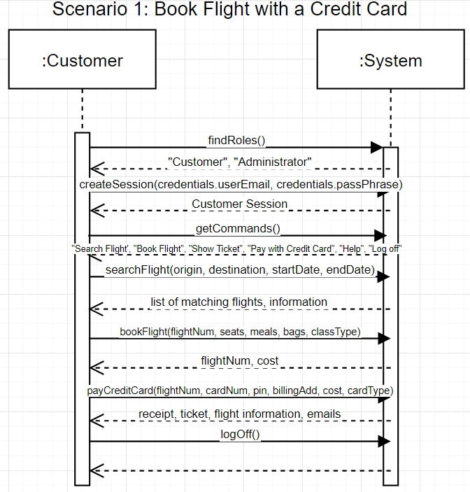

## Successfully Booking a Flight with a Gift Card

### Scenario Description

This scenario is almost identical to paying with a credit card, only with a few differences. A gift card contains a gift card “number”, which can contain alphabetical letters. There is no billing address required. The System responds with the remaining gift card balance. If there still is a balance remaining, the Customer will be notified. The balance returned will be zero if it has all been used. The Customer will need to request to pay with another payment method if there still is a remaining unpaid amount for the flight.

### System Sequence Diagram

